File Manager

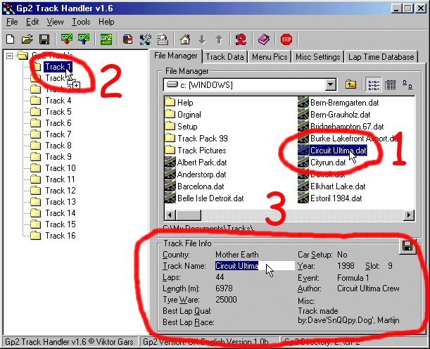
(File Manager)

Here is a screen shot of the File Manager.
In the big window on the right side you have all files and directory’s, it works the same way as the Open/Save dialogs that you will see when you use Windows.
When you click on a file (1) you will see information about the file below the File Manager (3), If it's a menu picture you have clicked on, you will see a preview of the picture below the File Manager (3).
On the left side you see a tree view (just as in Window Explorer). Here you will find 16 nodes, every node representing one track. To add a new track to track position 1, select the track in the File Manager (1) hold down the mouse and drag the file to the node that represents track position 1 in the tree view (2) and drop the file here. Now the node will be renamed to the track name. In this example the node will change name from “Track 1” to “1. Circuit Ultima”. If you now want to add a new menu picture to this track, select your menu picture in the File Manager (1). You will now see a preview of the picture below the File Manager (3), and do the same way as you did when you added a new track file. Hold down the left mouse button, drag the file to the track position you want to add the menu picture to and release the mouse button. You must have a track on the position where you want to add a menu picture.
When you click on a track file you can also change the info that is displayed below the File Manager (3), by clicking on the text (or if there is no text click where the text should be).You can’t change Car Setup and Author. To save your changes click on the save button in the top right corner of the Track File Info box (3).
New in v1.6 of Track Handler is that you can double click on a track file and the file will then be added to the first free track position in the tree view.

